Conference on Modelling Fluid Flow (CMFF’03)
The 12th International Conference on Fluid Flow Technologies
Budapest, Hungary, September 3 - 6, 2003
Experimental and numerical modelling of secondary emission control system of BOF (basic oxygen furnace)

Tamás LAJOS, professor*  Department of Fluid Mechanics  Budapest University of Technology and Economics | Gergely KRISTÓF, associate professor  Department of Fluid Mechanics  Budapest University of Technology and Economics
Jenő M. SUDA, assistant  Department of Fluid Mechanics  Budapest University of Technology and Economics | György FEHÉR, works manager  DUNAFERR  Danube Iron and Steel Corporation
Imre MÉSZÁROS, head of department

DUNAFERR
Danube Iron and Steel Corporation

*Corresponding author: Bertalan Lajos u. 4–6., H–1111 Budapest, Hungary
Tel.: (+36 1) 463 4072, Fax: (+36 1) 463 3464, Email: lajos@simba.ara.bme.hu

Abstract
In steel production serious environmental pollution occurs when hot iron is charged into the vessel filled partly with scrap. This is called secondary emission of BOF (basic oxygen furnace) technology. The hot fume escaping the vessel and entering the melt shop during the charging period consists of large quantity of solid particles, too. The aim of the studies reported here has been to improve the hood capture system by using both scale model experiments and numerical simulation of flow. Specific aspects of experimental investigations as well as details and results of numerical simulation with CFD code Fluent will be discussed.

Key Words: air pollution control, BOF secondary emission, numerical simulation
Nomenclature
g [N/kg] gravity
q [W] flux
p [Pa] pressure
v [m/s] velocity
CE [−] capture efficiency
D [m] diameter of vessel outlet
Fr [−] Froude number
Re [−] Reynolds number
T [K] temperature

Greek symbols
ν [m²/s] kinematic viscosity
ρ [kg/m³] density
Δ difference

Subscripts and Superscripts
a surrounding air
g hot gas
h hood
M model
Q heat
v vessel

1. INTRODuCTION
In metallurgy the air pollution sources are frequently hot gas jets consisting solid particles. The flow of these hot gases is strongly influenced by buoyancy forces. The air pollution caused by these hot gas jets can be prevent or reduce by using close hood capture systems. Their efficient and economic operation requires careful analyses of flow characteristic and appropriate design of hood and exhaust system.
The objective of the development of an emission control system is to remove air pollutants by exhausting the less possible amount of air. So the investment and operation costs (including the costs of gas cleaning) can be minimised. Basically there are two approaches of development and optimization of a hood capture system: model experiment and numerical simulation of flow.
At the beginning of production cycle at basic oxygen furnace steelmaking scrap will be transported into the inclined BOF vessel. Afterwards hot iron is poured from a charging ladle into the vessel. Figure 1 shows the sketch of the process [6] and the 3D numerical model of the vessel and the charging ladle.

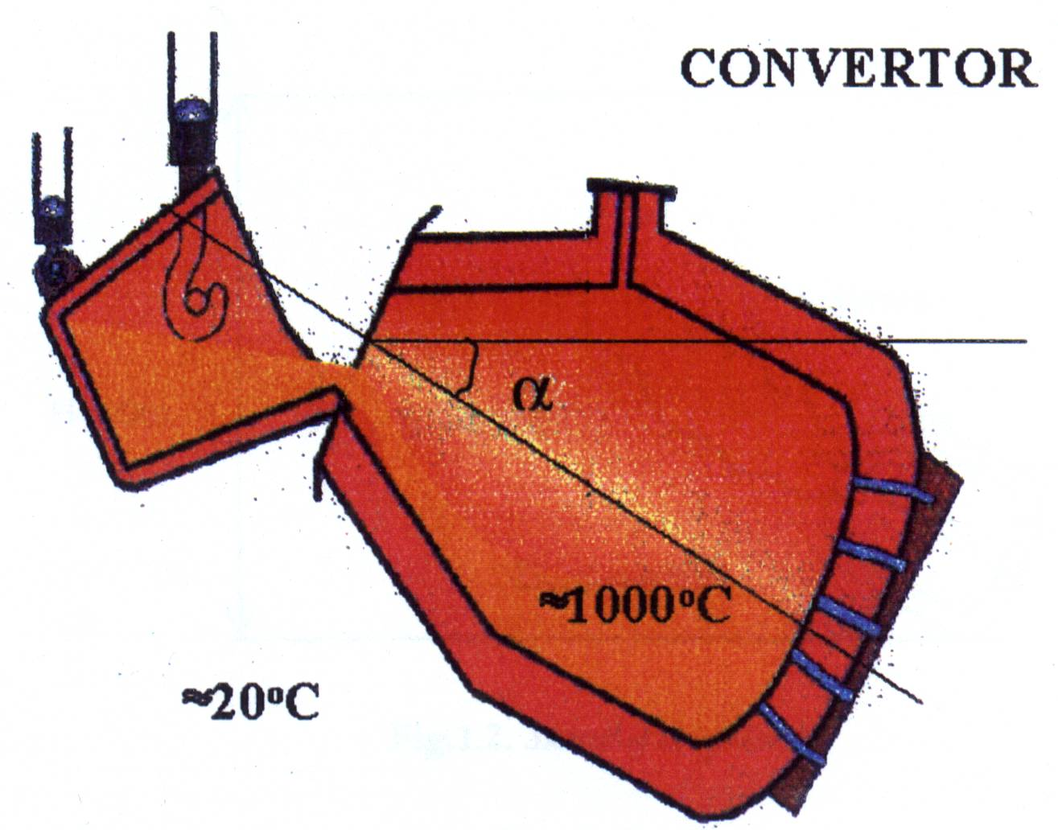

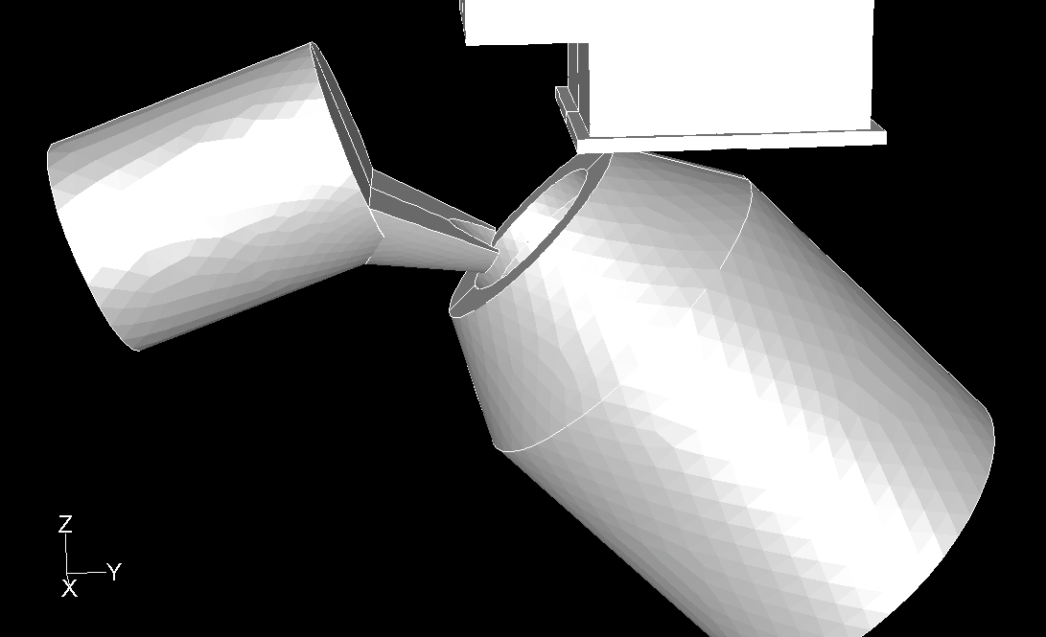
Figure 1. Charging the vessel and its 3D numerical model
During the charging the hot iron the scrap starts burning and hot gases (appr. 1000°C) escape through the opening of the vessel diameter of which is D=2.6 m (secondary emission of BOF). The gas velocity in the opening is about 8−10 m/s. The concentration of solid particles varies between 0.3 and 2.4 g/m³, its mass is in order of magnitude 10−20 kg/cycle [1]. Hot gas flows into the melt shop building and partly through windows near the roof in environment. In the investigations reported here addressed the reduction of secondary emission of a melt shop with two 120 tons vessels.
Because of the crane and the charging ladle the space available for close capture hood is rather limited so perfect removal of pollutants is in most cases impossible. That is why the close hood capture system is frequently combined with complete building evacuation.
In order to reduce the costs the secondary emission control system is usually connected to the primary system [2], [3], [4] removing and cleaning the pollutants escaping the vessel during oxygen blowing (primary emission). In this period the axis of vessel is vertical. The primary system starts with a capture hood (item 7 in Figure 2) connected to a boiler where oxidation of CO content of gas takes place and the hot gas will be cooled. The boiler is followed by a Venturi scrubber (item 10 in Fig. 2).

2. MODEL EXPERIMENTS FOR REDUCTION OF SECONDARY EMISSION

2.1 The model rig
Figure 2 shows the outline and the photo of the 1:20 scale model. The ambient air enters the test rig through pipe /1/ provided with orifice meter measuring the flow rate. The air is transported by blower /2/ into a chamber /3/ where it will be heated to about 5−600K by gas burners. The hot air flows into the inclined vessel model /5/ where perforated plate /6/ provides for uniform outflow through the opening. Part of warm air is captured by the hood /13/ and enters directly the primary emission control system /7/. In the proposed solution the capture hood is connected through a bypass pipe (indicated by dotted line /14/ in Fig. 2.) with the primary emission control system downstream the boiler just before the Venturi scrubber (see Figure 5). The flow rate of exhaust gas transported by fan /12/ is measured with orifice meter in pipe /11/. Also the charging ladle that changes its position during the pouring the hot iron in vessel has been modelled.
For measurement of flow rate, temperature and pressure in different parts of emission control system model PC controlled data acquisition and processing system has been used.

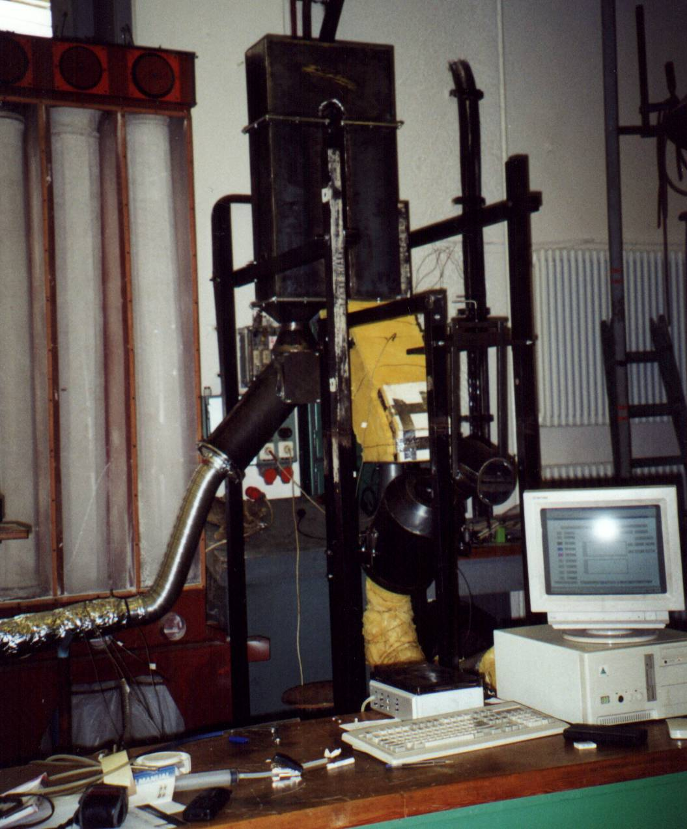
Figure 2. The experimental facility

2.2 Flow similarity
Since the shape of hot gas jet is of utmost importance from the point of view of operation of capture hood the similarity of flow is a significant precondition of reliability of experimental results.
In general identical Reynolds and Froude numbers at model and prototype ensure flow similarity. The characteristics of turbulent jets are in broad Reynolds number range not sensitive to the value of Reynolds number so only the turbulent flow in jet had to be ensured at the model experiments. The turbulent flow in the curved hot jet could be visualised quite easily: by transillumination of the hot air jet by an ordinary lamp the shadows show the details of flow field, so e.g. the turbulent eddies of the jet.
The motion of hot gas is mainly determined by the angle of inclination of the vessel as well as the ratio of inertial and buoyancy forces expressed by the Froude number [5], [6]. Inertial and buoyancy forces can be expressed by ρ_{g}D³v²/D and D³(ρ_{a}−ρ_{g})g, respectively. The ratio of two forces is the square of the Froude number as it is shown in Eq. (1).
${\text{Fr}}^{2}=\frac{ρ_{g}v^{2}}{D \left(ρ_{a}−ρ_{g}\right) g}$ (1)
Similar shape of hot fume jet in model and prototype is ensured if Fr_{M}=Fr. After transformations we obtain Eq. (2):
$v_{M}=v \sqrt{\frac{D_{M}}{D}\frac{{ΔT}_{M}}{ΔT}}$, (2)
where D_{M}/D is the model scale and ΔT [K] is the difference of hot gas and ambient air temperatures.
Model scale D_{M}/D=1/20 and temperature ratio ΔT_{M}/ΔT=1/2 was determined (hot gas jet has been modelled by hot air jet), so the outlet velocity of hot air ensuring the similarity of the jets: v_{M}=0.158⋅v. Outlet velocity in prototype (7−10m/s) has been determined approximately by using video recordings. Since Froude number is relatively small (Fr=1.2) buoyancy forces dominate in the flow. This effect could also be observed: the jet leaving the outlet of inclined vessel has turned shortly in vertical direction.

2.3 Evaluation of capture efficiency
In order to compare the different hood geometries and exhaust conditions a method for quantitative evaluation of the capture efficiency (CE) has been developed, based on measurement of ratio of heat flux entering the capture hood and that of discharged from the vessel CE=q_{QhM}/q_{QvM}·100%. Since temperature and velocity of warm air is quite uniform in the opening of the vessel, the heat flux leaving the vessel (that corresponds to the mass of pollutants to be removed) can be determined relatively easily by measuring the mass rate and the outlet temperature. On the contrary, the temperature and velocity distribution in capture hood and also in cross sections of primary emission control system is not uniform so the heat flux in removed gas (that corresponds to the mass of removed pollution) can only be measured by velocity and temperature measurement in several points of a cross section. To avoid this time consuming procedure the stratified air entering the capture hood has been mixed by using a labyrinth−like channel in the exhaust system (item /9/ in Fig.2.), developed by using numerical simulation of flow. Figure 3 shows the temperature equalization in the labyrinth calculated by using CFD code Fluent 5. In this way only the mass flow of removed gas and its mean temperature (that can be measured in a point after the labyrinth) have to be measured. To minimize the error caused by heat transfer through walls causing error in measurements the walls of vessel, hood and primary emission control facility have been provided with heat insulation (thickened walls in Fig.2.).

3. NUMERICAL SIMULATION OF FLOW
Numerical simulation of 3D flow has been carried out to collect experiences on the applicability of CFD in solution of air pollution control problems of metallurgy. Flow field, temperature distribution and capture efficiency of the secondary emission control system has been calculated at different pollutant and exhaust flow rate combinations at a given vessel and charging ladle position. Fluent 5 CFD code has been used.
Geometry of the simulation model has been scaled after the experimental setup so the outlet air velocity and temperature are taken from the laboratory scale model. Symmetry assumption with respect to the mid-plane of the facility has been employed in order to reduce the number of computational cells. The grid consisted of only tetrahedral cells and the number of cells was approximately 250000. The hot gas has been introduced to the computational domain through a velocity inlet, pressure outlets have been applied on the remaining boundary surfaces. Air density has been computed from incompressible ideal gas model as a function of local temperature. Time dependent simulation has been applied and turbulent transport has been computed with Renormalisation Group k−ε model.

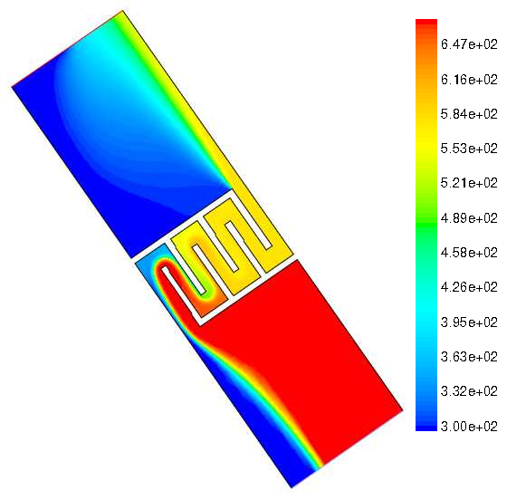
Figure 3. Temperature equalisation with labyrinth

4. RESULTS
A capture hood (Fig.2. item /13/, dotted line and Figure 5) fixed to the primary emission control hood and connected by a bypass pipe to the entrance of the Venturi scrubber has been planned to reduce the secondary emission. The aim of investigation has been the optimization of the geometry of capture hood and other part of primary and secondary emission control system as well as to minimize the flow rate of exhaust gas, necessary to reduction of pollution caused by secondary emission.
When comparing the shape of the hot jet in model with that of prototype a qualitatively good agreement has been found. An interesting and disadvantageous characteristic of the jets has been observed in both cases: in the second part of the hot iron charging when the position of upper open cross section of the charging ladle is increasingly steep the hot gas jet “adheres” to the open cross section. This phenomenon has been shown also by the numerical simulation (see Figure 4). Both the shape of the jet is of utmost importance with respect to capture efficiency, which underlines the significance of the proper modelling: the identical values of Froude number at model and prototype, shown above.
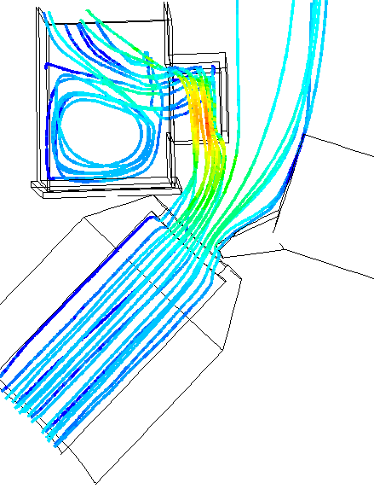
(a)
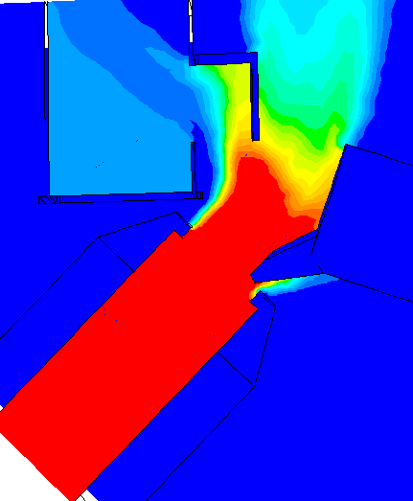
(b)
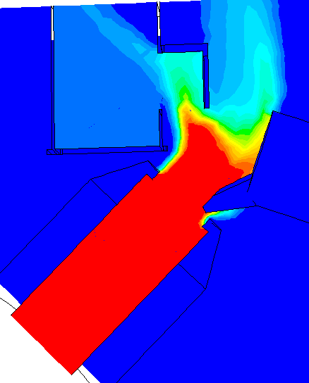
(c)
Figure 4. Streamlines (a) and temperature distribution (b) at the beginning of charging at nominal pollutant discharge and exhaust condition CE=57%; and temperature distribution (c) with doubled exhaust flow rate CE=86%.
The effects of a number of variables on capture efficiency have been measured: velocity in the outlet of the vessel, exhaust flow rate, inclination angle of the vessel, position of the charging ladle relative to the vessel outlet, the depth and width of capture hood, operation of the primary emission control system.
The results of experimental investigation and numerical simulation of the flow are the following:
(a) As expected the capture efficiency was mostly affected by the exhaust flow rate and pollutant discharge flow rate.
(b) The angle of inclination of the vessel, i.e. the direction of hot jet at the outlet of the vessel as well as the position of charging ladle influences the capture efficiency (CE) significantly. The steeper is the axis of the vessel and the steeper is the upper open cross section of the charging ladle the higher is the value of CE. Unfortunately the advantageous conditions make the work of crane operator difficult.

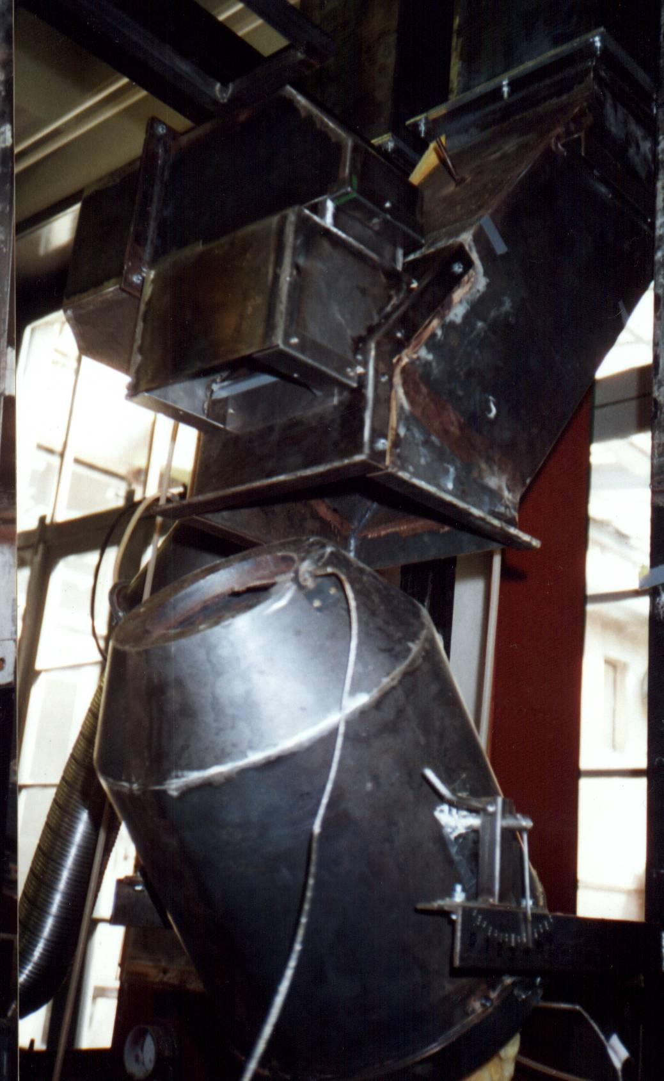
Figure 5. The vessel and the proposed capture hood
(c) The width of the hood has been optimised. Because of the buoyancy the hot gas jet accelerates upwards and so the width of its cross section remains relatively small at the height of the hood inlet. In this way the optimal width of the hood could be found where the capture efficiency is close to maximum and the flow rate of removed gas is relatively limited. The capture efficiency increased with the depth of to hood, which is limited by the position of the crane and the charging ladle. So, unfortunately the depth of the hood could not be optimized: the possible largest size has been selected.
(d) Measurements have shown that the primary emission control system should be closed upstream the junction of the bypass pipe during charging the vessel in order to ensure adequate exhaust flow rate in the capture hood. To avoid 20−30% reduction of the flow rate in primary emission control system the bypass pipe should be closed during the blowing of oxygen.
(e) Since the capture efficiency is very much influenced by the position of the charging ladle: by using the hood of proposed (optimized) geometry capture efficiency CE=0.87 has been measured without charging ladle. In the first part of the charging process the capture efficiency first decreased to CE_{min}=0.54 because of interaction of jet and ladle discussed above and shown by Fig.4.(b) and (c). At the end of the charging when the open cross section of the ladle approaches the vertical the capture efficiency increases rapidly and reaches 100%. So the average capture efficiency (estimated to 75−85%) depends on the pace of the charging determined also by the crane operator. To improve the capture efficiency the construction of the charging vessel should be changed in order to avoid the “adherence” of the jet to the charging ladle.
(f) The results of 3D numerical simulation of the flow by using Fluent 5 are qualitatively and quantitatively in good agreement with that of the measurements and contributed very much to better understanding of the flow processes and in this way to shorten and/or replace the experimental work.

7. CONCLUSION
(i) Experimental investigations on scale model are reliable tools of development of air pollution control systems in metallurgy, removing in general hot gases. In order to ensure the flow similarity Froude number at prototype and model should be identical.
(ii) Measurement and comparison of exhaust and discharge heat fluxes proved to be suitable method for determination of capture efficiency of the pollution control system.
(iii) The interaction of the jet with charging ladle influences the capture efficiency significantly.
(iv) The results of the 3D numerical simulation agreed well with the results of measurements, so CFD can efficiently be used for solving similar problems air pollution control problems in metallurgy.

References
[1] “Szakvélemény a Dunai Vasmű konvertertest feletti gáz- ás porelszívás szükséges mértékére” (3/50−4646/2) OMTKI (1991)
[2] Cesta, T. and Wrona, L., 1995, “Optimization of BOF air emission control systems” Iron and Steel Engineers, (1995 July)
[3] Cesta, T, Kumar, S. and Linkruus, K., 1989, “Design and investigation of gas handling system” International Symposium on Process Gas Handling and Cleaning, Halifax, Nova Scotia, pp.88−100.
[4] Safe, P. and Wiggins, B., 1993, “Improving the efficiency of an existing BOF meltshop emission control system” Iron and Steel Soc. Process Technology Conference Proceedings, 1993, Vol.12. pp.73−79.
[5] Lajos, T., 2000, Az áramlástan alapjai, Műegyetemi Kiadó
[6] Morales, M.V., 1999, “Characterisation of a Inclined Buoyant Jet” von Karman Institute for Fluid Dynamics, VKI−PR 1999/33.

